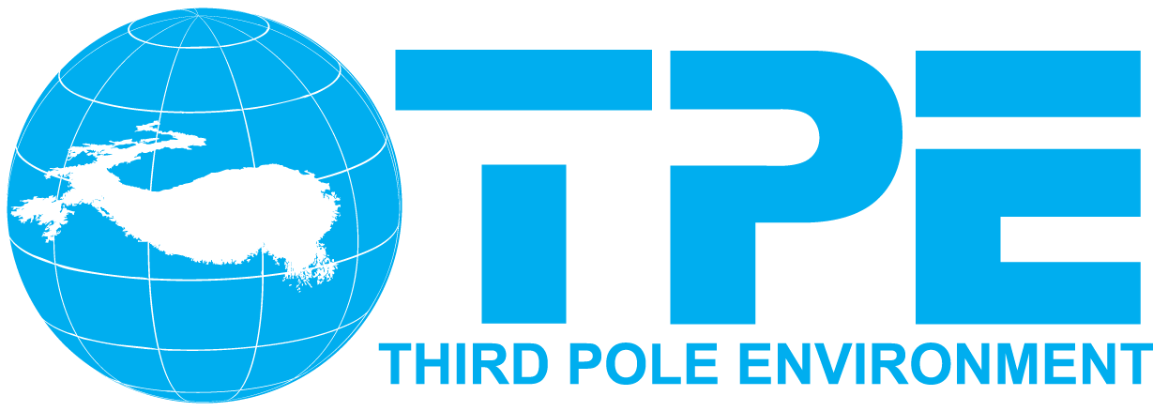

**International Workshop on Land Surface Multi-spheres Processes of Tibetan Plateau and their Environmental and Climate Effects Assessment**

*First Circular*

August 8-11, 2016 Xining, China

**Organized and Sponsored by:**

Third Pole Environment (TPE)

Institute of Tibetan Plateau Research, Chinese Academy of Sciences (ITPCAS)

University of California at Los Angeles (UCLA)

CAS Center for Excellence in Tibetan Plateau Earth Sciences (CETES)

The China Society on Tibetan Plateau (CSTP)

Chinese Academy of Sciences (CAS)

American Geophysical Union (AGU)

National Natural Science Foundation of China (NSFC)

U.S. National Science Foundation (NSF)

Ministry of Science and Technology of the People’s Republic of China (MOST)

The Ohio State University (OSU)

Northwest Institute of Plateau Biology, CAS (NWIPB)

Chinese Academy of Meteorological Sciences (CAMS)

Jiangsu Collaborative Innovation Center for Climate Change, Nanjing University

Chengdu University of Information Technology (CUIT)

The Chinese-American Oceanic and Atmospheric Association (COAA)

International Centre for Integrated Mountain Development (ICIMOD)

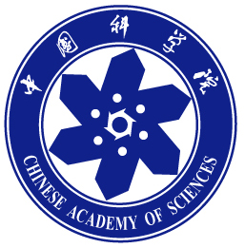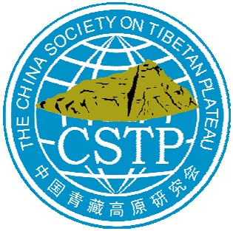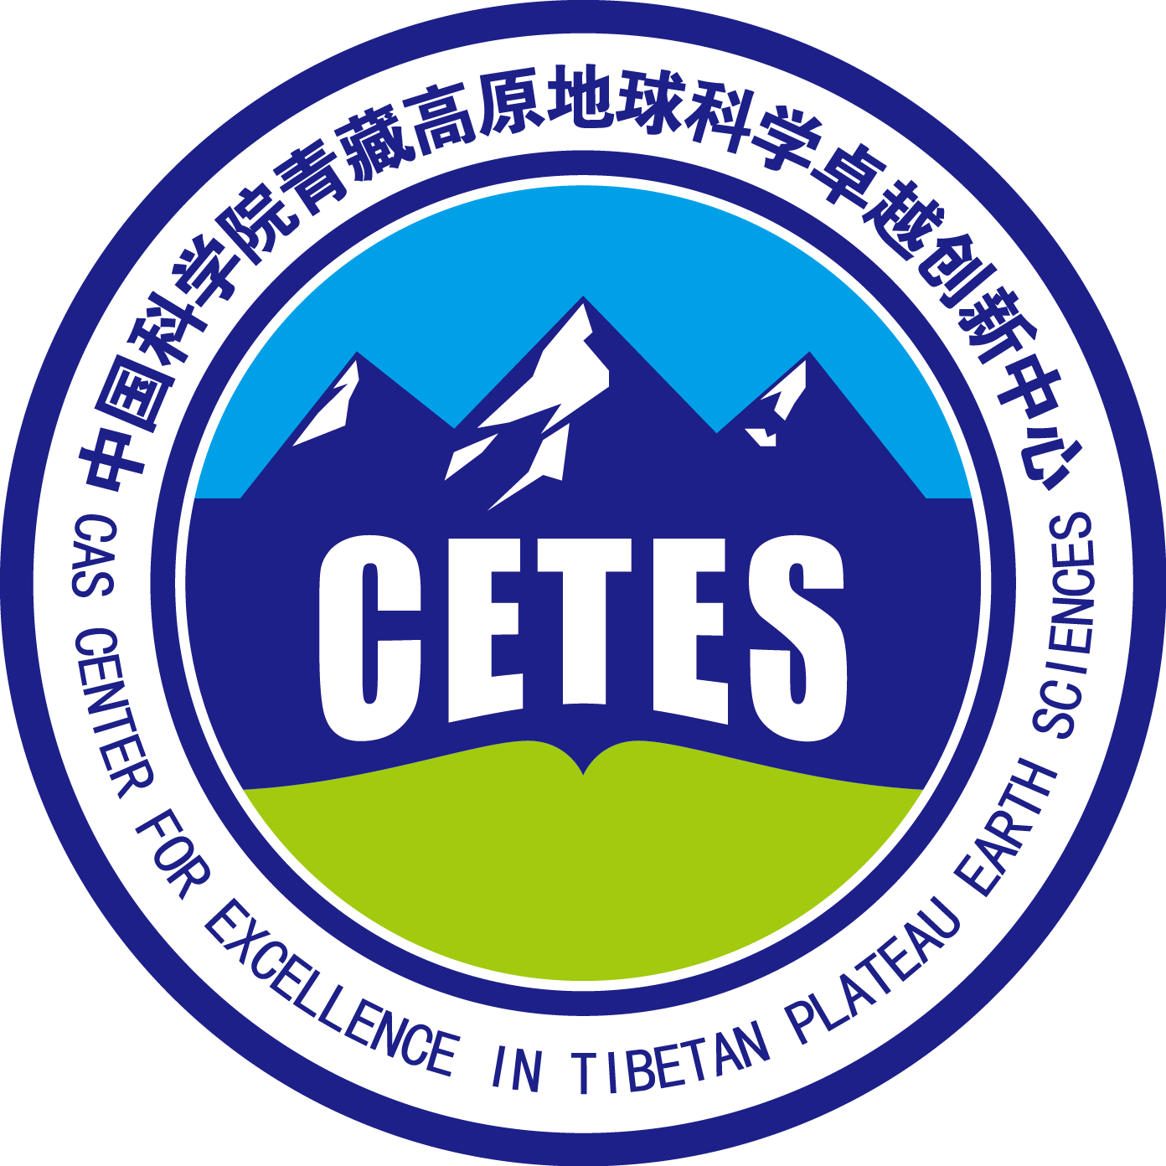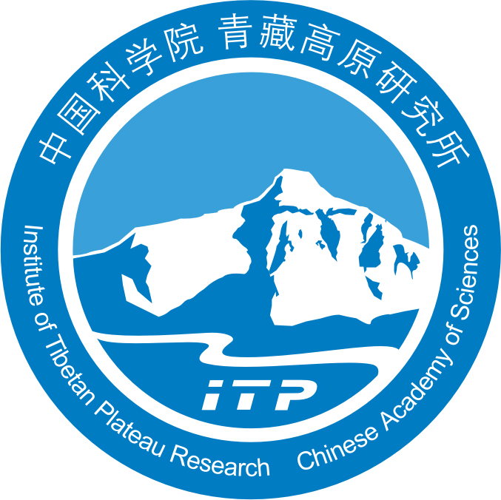





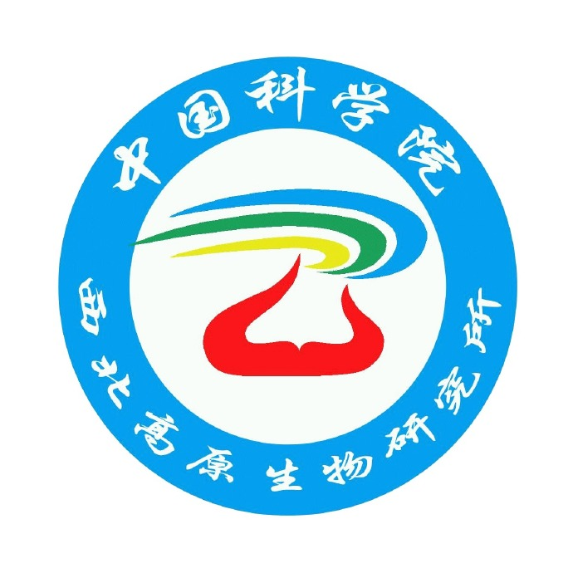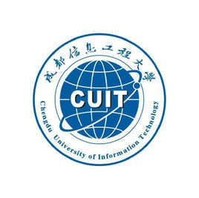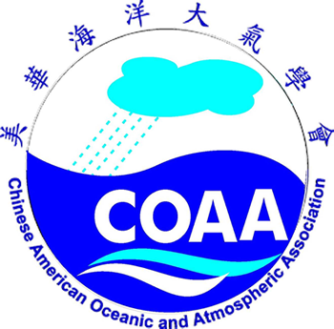

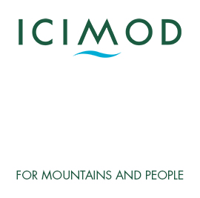

­

**ANNOUNCEMENT**

The International Workshop on Land Surface Multi-spheres Processes of Tibetan Plateau and their Environmental and Climate Effects Assessment will be held on August 8-10, 2016 in Xining, China.

**BACKGROUND**

The Tibetan Plateau (TP) is a unique geographic region including the Himalayas and other surrounding mountain ranges. The TP is the highest and most extensive highland in the world and exerts a huge influence on regional and global climate and hydrology through dynamic, mechanical, and thermal forcing mechanisms. The headwater areas of many major rivers in the eastern part of Asia are located in TP. Therefore, surface conditions over the TP have always been an important research topic in earth science. In the past several decades, significant progress has been achieved in understanding the conditions of TP’s surface and climate through both observational and theoretical researches. Meanwhile, new scientific problems have been identified and require further in-depth studies. In the 21st century, understanding the TP’s role in the global climate and environmental variability and change has become more prominent and has gained more scientific attention in light of the global warming. The unique interactions among the land surface multi-spheres (cryosphere, hydrosphere, lithosphere, biosphere and anthroposphere) over the TP and their interactions with atmosphere significantly influence social and economic development of surrounding countries.

With the improvement in field measurements, remote sensing techniques and integrated observations, the TP scientific research is likely to experience a critical period of rapid development. It is also imperative for academic community to make an assessment on the Tibetan environment.

The workshop on Land Surface Multi-spheres Processes of Tibetan Plateau and Their Environmental and Climate Effects Assessment aims to bring together professionals from world in different disciplines to exchange ideas and research findings to broaden the interdisciplinary collaborations on these aspects of the TP scientific researches, and to bridge existing knowledge gaps for international and interdisciplinary collaborations, and to make an assessment of the Tibetan environment.

This workshop will focus on the understanding of TP’s climate and environment (both paleo and contemporary), cryosphere, lithosphere, and terrestrial surface conditions and the regional and global impact of their interactions on the TP regions and global climate and environment using both observational and modeling approaches. The workshop topics include, but are not limited to, climate and environmental changes and variability, especially those associated with Asian monsoons, over TP and adjacent regions, regional climate predictions and future projections, hydrological and energy cycles and their anomalies, climate change and its impacts, TP atmospheric circulation features and anomalies, interactions between Asian monsoon and surrounding oceans, source, transport and spatial/temporal distributions of aerosols and their effect on cryosphere and climate, remote sensing applications in analyzing and understanding these processes, and parameterizations of the TP land surface processes and their utilities in climate and weather prediction models.

**THEMES**

Overarching themes of the workshop include but are not limited to:

1. **Regional and Global Implication of Land Surface Multi-spheres Processes over TP**
2. Characteristics of circulation, energy and hydrological cycles and other physical processes over TP and impacts of their interactions on the monsoon system
3. Applications of ground measurements, proxy records (ice core, lake sediment), stable isotopes, major ionic chemistry, as well as remote sensing in analyzing and understanding land surface multi-spheres processes
4. Parameterization of surface characteristics over TP and its application in regional climate predictions; evaluation of climate models’ performances over TP
5. Aerosol-cloud-radiation interactions over TP and their climate impact
6. Ecosystem dynamics, climate change and anthropogenic impact on TP
7. Cryosphere and hydrological processes on TP and their impacts
8. **TP Environmental Assessment**
9. Land surface multi-spheres processes over the TP: past changes, current conditions and future projections at different scales
10. Interactions among land surface multi-spheres, their consequences and impact on society over the TP
11. Societal strategy to the changing TP environment

**SCIENTIFIC PROGRAM COMMITTEE**

Prof. YAO Tandong, Institute of Tibetan Plateau Research, CAS

Prof. Yongkang Xue, University of California at Los Angeles

Prof. Lonnie G.Thompson, Byrd Polar and Climate Research Center and the School of Earth Sciences, The Ohio State University

Prof. Deliang Chen, University of Gothenburg

Prof. Volker Mosbrugger, Senckenberg Research Center for Nature Study

Prof. Samuel Shen, San Diego State University

Prof. GUO Zhengtang, Institute of Geology and Geophysics, CAS

Prof. CUI Peng, Institute of Mountain Hazards and Environment, CAS

Prof. ZHOU Xiuji, Chinese Academy of Meteorological Sciences

Prof. WU Guoxiong, LASG, Institute of Atmospheric Physics, CAS

Prof. ZHANG Renhe, Chinese Academy of Meteorological Sciences

Prof. FU Congbin, Nanjing University

Prof. Toshio Koike, University of Tokyo

Prof. CHEN Fahu, Lanzhou University

Prof. Lü Shihua, Chengdu University of Information Technology

**ORGANIZATIONAL COMMITTEE**

Prof. YAO Tandong, Institute of Tibetan Plateau Research, CAS

Prof. Yongkang Xue, University of California at Los Angeles

Prof. Lonnie G.Thompson, Byrd Polar and Climate Research Center and the School of Earth Sciences, The Ohio State University

Prof. Samuel Shen, San Diego State University

Prof. XU Xiangde, Chinese Academy of Meteorological Sciences

Prof. MA Yaoming, Institute of Tibetan Plateau Research, CAS

Dr. Jin Huang, The Chinese-American Oceanic and Atmospheric Association

Prof. GUO Weidong, Nanjing University

Prof. LIU Yimin, LASG, Institute of Atmospheric Physics, CAS

Prof. Xiquan Dong, University of North Dakoda

Dr. Shiori Sugimoto, Japan Agency for Marine-Earth Science and Technology

Prof. FAN Guangzhou, Chengdu University of Information Technology

**LOCAL ORGANIZATIONAL COMMITTEE**

Prof. YAO Tandong, Institute of Tibetan Plateau Research, CAS

Prof. MA Yaoming, Institute of Tibetan Plateau Research, CAS

Prof. ZHU Liping, Institute of Tibetan Plateau Research, CAS

Prof. XU Baiqing, Institute of Tibetan Plateau Research, CAS

Prof. PIAO Shilong, Institute of Tibetan Plateau Research, CAS

Prof. Zhao Ping, Chinese Academy of Meteorological Sciences

Dr. AN Baosheng, Institute of Tibetan Plateau Research, CAS

Prof. ZHANG Fan, Institute of Tibetan Plateau Research, CAS

Dr. YANG Xiaoxin, Institute of Tibetan Plateau Research, CAS

Dr. WANG Weicai, Institute of Tibetan Plateau Research, CAS

Prof. ZHANG Yu, Chengdu University of Information Technology

Prof. CAO Guangmin, Northwest Institute of Plateau Biology, CAS

**ABSTRACT SUBMISSIONS**

The deadline for abstract submission is **April 15, 2016**. Please submit your abstract by email to Dr. Weicai Wang, ITPCAS at: [weicaiwang@itpcas.ac.cn](mailto:weicaiwang@itpcas.ac.cn) or [tpe@itpcas.ac.cn](mailto:tpe@itpcas.ac.cn)

**Guidance for abstracts:**

1) Abstracts should include focused scientific results on either theory or applications.

2) The abstract submission does not require a fee.

3) The abstract submitting person will automatically be the lead author unless otherwise indicated.

4) Submission of an abstract implies the obligation to give a presentation in the designated manner defined by the Program Committee, and grants the abstract publication right.

5) Abstract length limit: The abstract text is limited to maximum 600 words. The words count does not include the title, author names, affiliations, tables and images.

6) Tables and images: An abstract may include up to two tables, or two images, or one table and one image. Tables and images should be placed at the end of an abstract.

Questions and Answers: If you have questions regarding the submission or the workshop, please contact the organization committee at [tpe@itpcas.ac.cn](mailto:tpe@itpcas.ac.cn).

**VENUE AND ACCOMMODATIONS**

The conference will be held at Xining. Registration and hotel reservation information will be available in the second announcement.