International Workshop on Land Surface Multi-spheres Processes of Tibetan Plateau and their Environmental and Climate Effects Assessment

August 8-10, 2016 Xining, China

LOGISTICAL and TRAVEL INFORMATION FOR PARTICIPANTS

Local Organization Committee
May 24, 2016

Greetings Participants!

It is our great pleasure to welcome you to the International Workshop on Land Surface Multi-spheres Processes of Tibetan Plateau and their Environmental and Climate Effects Assessment to be held in Xining, China, August 8-10, 2016. We are confident that your active participation and contribution will make the workshop a grand success. Please use the enclosed information to help plan your trip to Xining, China and attendance at the workshop.

If you have any further questions or need additional assistance, please don’t hesitate to contact the Local Organizational Committee members as listed below. We look forward to seeing you soon in Xining!

Contact
Mr. Zhiqiang Liu, zqliu@itpcas.ac.cn (Hotel and field trip),
Dr. Chao Xu, xuchao@itpcas.ac.cn (Airline Ticket),
Dr. Chao You, youchao@itpcas.ac.cn (Pick-up),
Ms. Fan Ping, pingfan@itpcas.ac.cn (others)
No. 16 Lincui Rd, Chaoyang District,
Beijing, 100101, P.R. China
TEL: 86-10-84249468, 84249465
Email: tpe@itpcas.ac.cn
Web: http://xining2016.tpe.ac.cn/
https://easmea-outreach.geog.ucla.edu/xining2016/

Meeting Venue and Accommodation

The International Workshop on Land Surface Multi-spheres Processes of Tibetan Plateau and their Environmental and Climate Effects Assessment will be held at the Xining Hotel (Xining Bin Guan).

Accommodation has also been arranged in the same hotel. The Local Organizational Committee (LOC) has negotiated a preferential rate for the rooms. Please fill the attached hotel reservation form regardless whether you receive the travel support from the meeting and submit it to zqliu@itpcas.ac.cn before June 5, 2016. For those who will support by themselves, the meeting LOC will make reservation for you after receiving your form. You will make the payment to the hotel after you arrive.
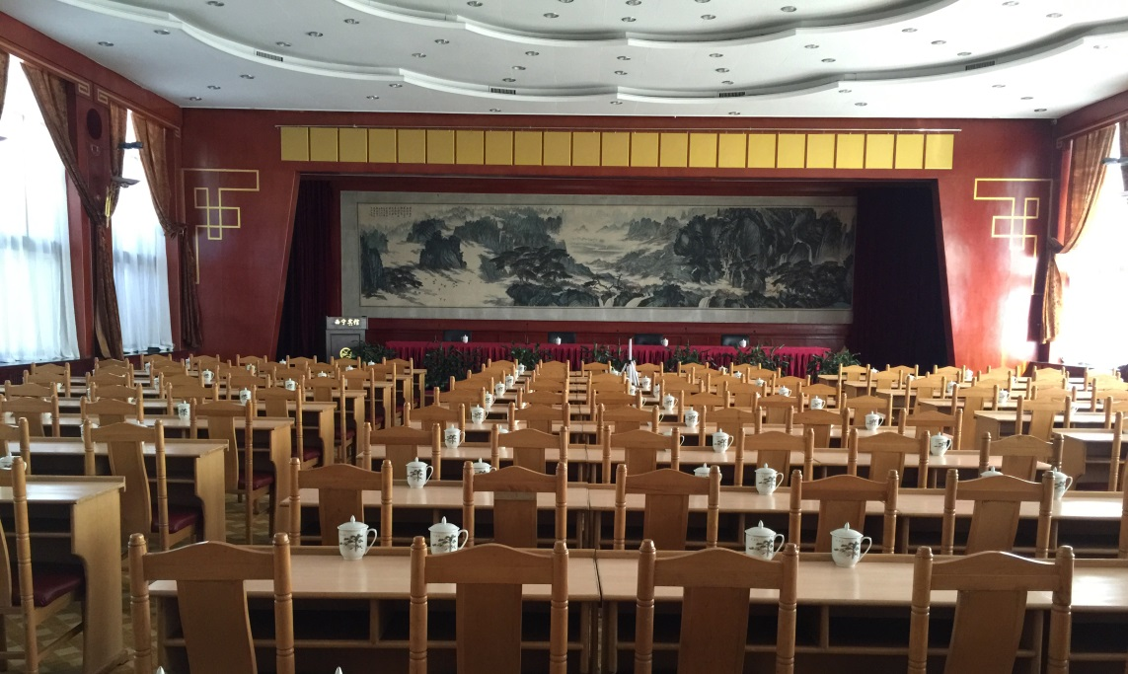
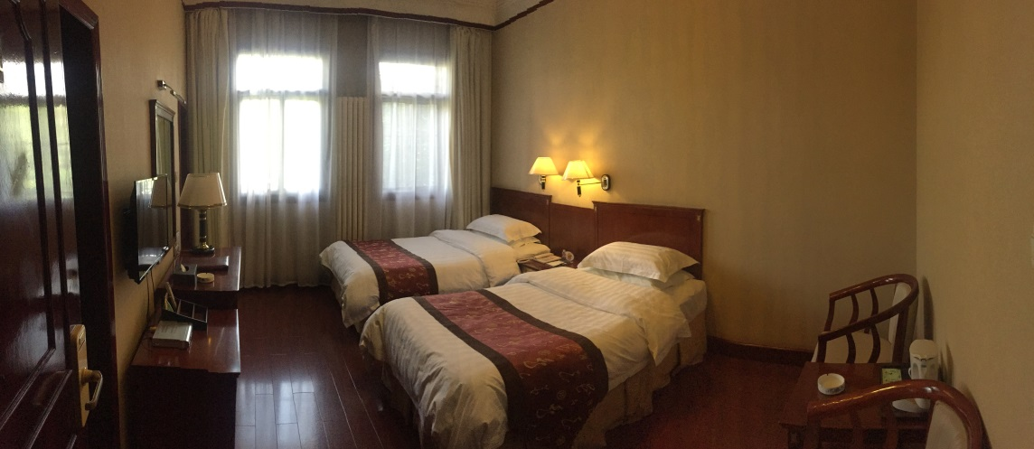
Xining Hotel
No. 348, Qiyi Road, Chengzhong District, Xining, Qinghai, China
Tel: 86-971-8461000 Fax: 86-971-8450798
Ground Transportation

Xining hotel is ~35 km away from Xining Caojiabao airport (IATA: XNN, ICAO: ZLXN). We will be arranging a schedule of pickup times based on the arrival times of the participants on August 7 regardless whether you receive the travel support from the meeting.
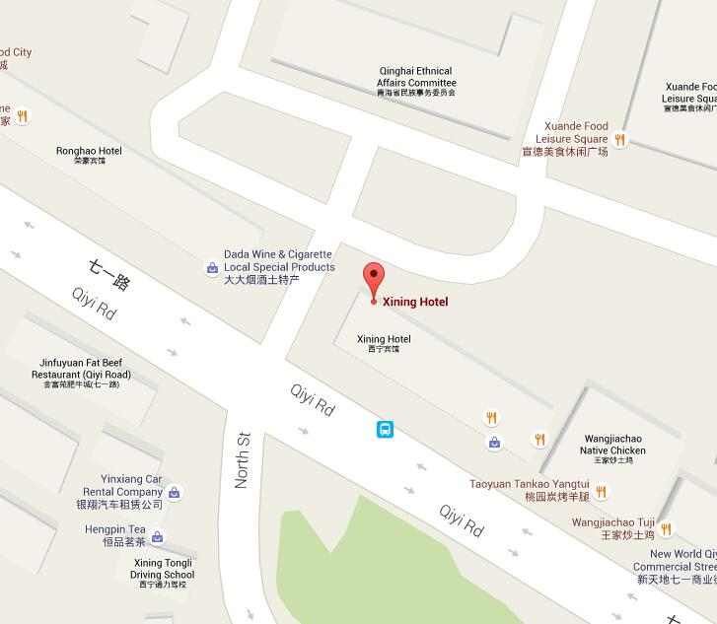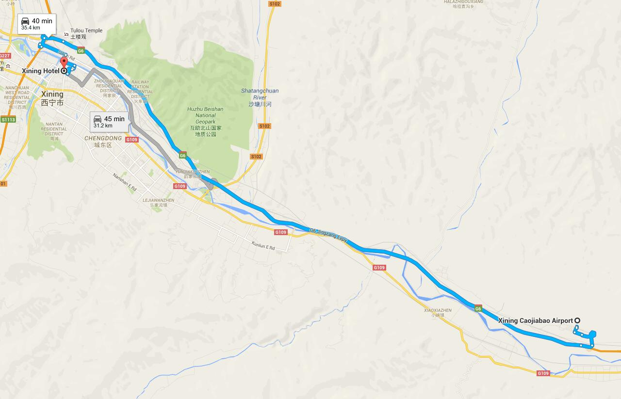
Travel from Beijing to Xining and Hotel Reservation
The participants receiving either full or domestic travel support should arrive at Beijing on August 6. The Local Organizational Committee (LOC) will buy the air ticket between Beijing and Xining. We will collectively go to Xining on August 7. The date of return from Xining to Beijing will depend on whether you join the field trip. For those who support by themselves but also want to go to Xining collectively with other participants, please contact LOC for your intention.

Note to participants receiving travel support

For the participants who receive international travel support, the workshop will reimburse the cost of an economy class (most direct route) of international round-trip ticket. Reimbursements will be made upon receipt of original invoice /e-ticket receipts and boarding passes. We highly recommend that you book your international tickets ASAP and request reimbursement during the workshop.

For participants who receive international and/or domestic travel support, please send your scanned passport to zqliu@itpcas.ac.cn before June 5, 2016 along with the hotel reservation form.

Hotel Reservation Form

Please complete the form and submit it to zqliu@itpcas.ac.cn before June 5, 2016.

Name |  |  |  | Nationality |  |  |  | Sex
Affiliation
Position |  |  |  |  |  |  |  | Title
Telephone |  |  |  |  |  |  |  | Mobile
Email
Travel Support | Meeting Support |  |  |  |  | Self-Support
Room Reservation
Content | Select (√) | Content |  |  | Quantity |  | Content |  |  |  | Select (√)
Single |  | Number of Single Room (380 RMB) |  |  |  |  | No Need for Hotel Room
Double |  | Number of Double Room (400 RMB) |  |  |  |  | Room Sharing Needed
Suite |  | Number of Suite Room (680 RMB)
Length of Stay | Date of arrival at Xining:
 | Date of departure from Xining:
Note

